**India’s Agricultural Crop Production Analysis(1997-2021)**

# INTRODUCTION

* 1. 1.1 Overview

A brief description about your project

This report delves into the captivating realm of India's agricultural cultivation, providing a comprehensive visual exploration of key aspects and trends in the agricultural sector. Through the visual representations, readers can gain valuable insights into crop production, seasonal variations, regional distribution, and overall production trends. These visualizations enable intuitive analysis, allowing stakeholders to uncover patterns, identify areas of growth or concern, and make data-driven decisions.

By harnessing the power of Tableau, this report not only presents the data in a visually appealing manner but also provides an interactive experience for readers to explore the intricacies of India's agricultural cultivation. To Extract the Insights from the data and put the data in the form of visualizations, Dashboards and Story we employed Tableau tool.

* 1. 1.2 Purpose

Conventionally, crop cultivation technologies are improved by developing (creating) more effective elements and implementing them in a fragmented way using a transformational approach. It has been found that a morphological approach is more promising and effective for these purposes when creating and implementing the holistic production agricultural technologies and the corresponding technological systems. For its implementation, the methods of engineering design of complex systems are proposed to be used. The presented paper outlines the main methodological issues of engineering technological design of agricultural cultivation technologies. The purpose of the research is the development of methodological provisions for the formation and selection of promising technological processes in technological modules when cultivating crops. To form options of technologies, the methods of morphological analysis are used. When selecting acceptable, promising and effective options for the designed projects, the decision-making theory methods are used. The analysis of scientific works shows that almost all the presented models have the same drawback: the lack of a mechanism for the formation and selection of promising technological processes implemented in a particular technology and so far, there is no effective methodological approach for its implementation. According to the results of scientific research, it was found that in the formation of systems of mechanization of plant growing processes, it is advisable to use the methods and techniques of engineering design of individual technological processes and technical equipment that have not been developed so far. A block hierarchical approach to the designing of crop production agricultural technologies is proposed. In the design process, the following basic principles must be maintained: a systematic approach, focus on obtaining optimal solutions, a comprehensive (multi-criteria) approach, a functional approach, iterative design process, focus on the final result, a combination of formalized and heuristic methods, the principle of open systems, the principle of modeling objects, the principle of functional completeness, etc. A general logical scheme of the process of engineering design of agricultural plant technology objects is proposed, where the main stages and design stages, design tasks and the main methods for solving them are define

**2. Problem Definition & Design Thinking**

* 1. 2.1 Empathy Map

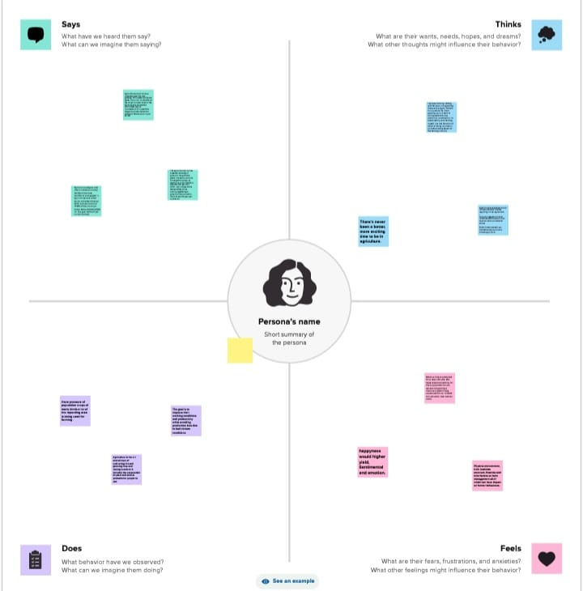

* 1. 2.2 Ideation & Brainstorming Map

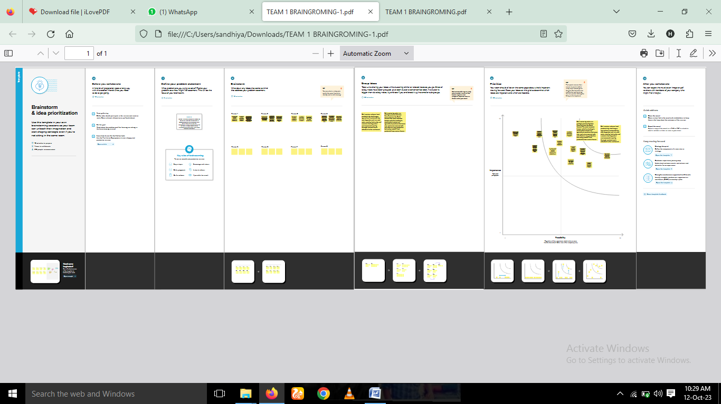

# 3.RESULT

Story 1

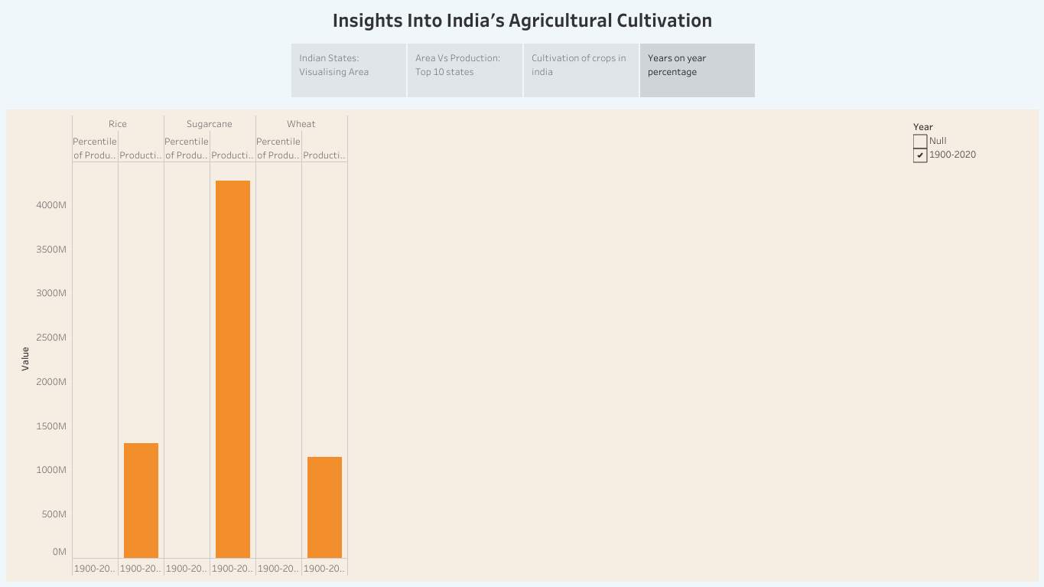

Story 2

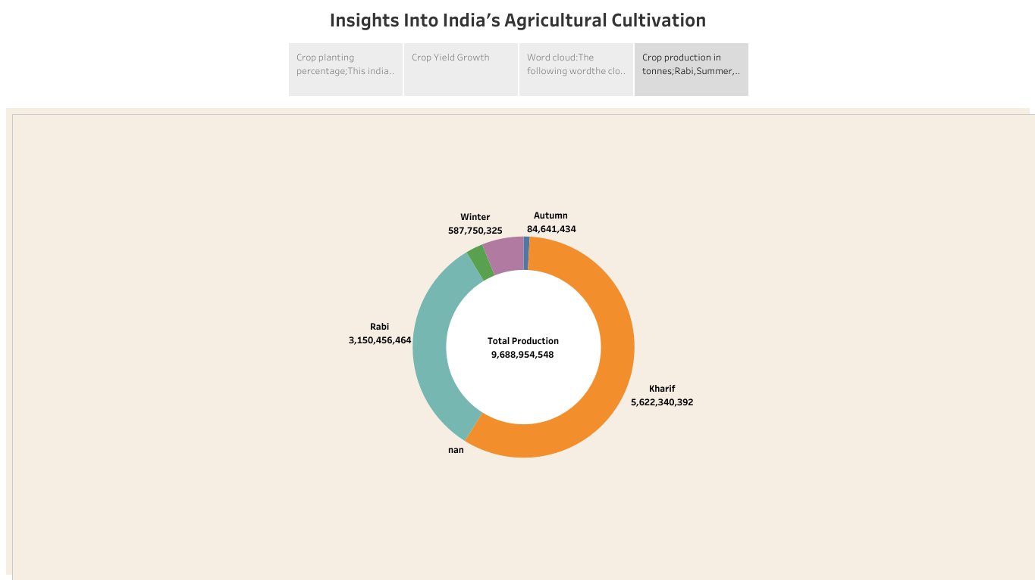

# 4.ADVANTAGES & DISADVANTAGES

ADVANTAGES

Advantages of Modern Agriculture

Increased Efficiency – Modern farming methods are more efficient than traditional methods, with advanced machinery and equipment, allowing farmers to produce larger quantities of crops in less time and with less labor.

Improved Crop Quality – The use of advanced techniques such as precision farming and genetic engineering has led to the development of higher quality crops that are more resistant to pests and disease.

Reduced Environmental Impact – Modern agriculture techniques are designed to be more sustainable, with a focus on reducing waste, conserving resources, and minimizing the use of harmful chemicals.

Increased Food Production – Modern agriculture has enabled farmers to produce larger quantities of food, helping to address food shortages and hunger in many parts of the world.

Economic Benefits – Modern agriculture has had a positive impact on the economy, by creating jobs and generating revenue for farmers, agribusinesses, and related industries.

DISADVANTAGES

Disadvantages of Modern Agriculture

Soil Degradation – The intensive use of modern farming practices, such as heavy use of chemical fertilizers and pesticides, can lead to soil degradation over time, reducing soil fertility and leading to erosion.

Biodiversity Loss – Modern agriculture can have a negative impact on biodiversity, with the use of monoculture and genetically modified crops leading to a loss of natural diversity in plant and animal species.

Water Pollution – The excessive use of chemical fertilizers and pesticides in modern agriculture can lead to runoff and contamination of nearby water sources, potentially harming aquatic ecosystems and human health.

Health Risks – The use of chemicals in modern agriculture can pose health risks to farmers and farm workers who are exposed to these chemicals on a regular basis.

Food Safety Concerns – The use of genetically modified crops and hormones in modern agriculture has raised concerns about the safety of the food supply, with some studies suggesting potential long-term health effects.

# 5.APPLICATIONS

[**Agricultural Applications**](https://www.lawinsider.com/dictionary/agricultural-applications)

means applications relating to (i) cultivating, characterizing or modifying soil; (ii) producing, growing, improving, protecting, treating or modifying crops or forest products; (iii) raising, harvesting, improving, protecting, treating or modifying livestock, poultry, fish or shellfish; and (iv) the preparation, marketing or treatment of products resulting from the activities described in (i)-(iii) above. Agricultural Applications shall include applications involving the improvement or modification of soil, crops, livestock, poultry, fish or shellfish and their resulting products as they relate to human health, as well as foods from plants and animals designed or modified to enhance their health attributes, in each case for nutraceutical applications but not therapeutic applications in humans. Agricultural Applications shall also include agricultural applications relating to bacteria, fungi, and viruses, as well as pest organisms with respect to, and only to the extent of, such bacteria, fungi, viruses or pest organisms' interaction with soil, plants, livestock, poultry, fish or shellfish. For avoidance of doubt it is acknowledged and understood that Agricultural Applications includes genes and gene-based or genetic technologies useful for achieving the above described activities, in particular: - Gene-based diagnostics of agricultural pests; - Gene-based analysis of metabolism of pesticides in plants and pest organisms; - Gene-based analysis of metabolism and physiological state of plants; livestock, poultry, fish, shellfish, or their pests; - Genetic modification of pest organism for functional analysis of pest-related properties; - Genetic modification of pest, bacteria, fungi, or viruses for functional analysis and optimization as protectants or growth stimulators of plants, livestock, poultry, fish or shellfish; - Functional genetic analysis of the genomes of plants, livestock, poultry, fish, or shellfish or their pest for applications in agriculture; - Genetic modification of plants, livestock, poultry, fish, or shellfish or their pests with the goal of enhancing properties relevant to production and end-use (i.e.; input and output traits); - Gene-based diagnostics for determining seed and crop composition and quality; and - Gene-based markers for facilitation of the breeding of plants, livestock, poultry, fish, or shellfish or their pests for applications in agriculture. Agricultural Applications shall further include food safety applications relat...

The development and implementation of precision agriculture or site-specific farming has been made possible by combining the Global Positioning System (GPS) and geographic information systems (GIS). These technologies enable the coupling of real-time data collection with accurate position information, leading to the efficient manipulation and analysis of large amounts of geospatial data. GPS-based applications in precision farming are being used for farm planning, field mapping, soil sampling, tractor guidance, crop scouting, variable rate applications, and yield mapping. GPS allows farmers to work during low visibility field conditions such as rain, dust, fog, and darkness.

In the past, it was difficult for farmers to correlate production techniques and crop yields with land variability. This limited their ability to develop the most effective soil/plant treatment strategies that could have enhanced their production. Today, more precise application of pesticides, herbicides, and fertilizers, and better control of the dispersion of those chemicals are possible through precision agriculture, thus reducing expenses, producing a higher yield, and creating a more environmentally friendly farm.

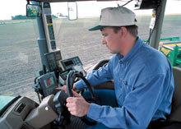Precision agriculture is now changing the way farmers and agribusinesses view the land from which they reap their profits. Precision agriculture is about collecting timely geospatial information on soil-plant-animal requirements and prescribing and applying site-specific treatments to increase agricultural production and protect the environment. Where farmers may have once treated their fields uniformly, they are now seeing benefits from micromanaging their fields. Precision agriculture is gaining in popularity largely due to the introduction of high technology tools into the agricultural community that are more accurate, cost effective, and user friendly. Many of the new innovations rely on the integration of on-board computers, data collection sensors, and GPS time and position reference systems.

Many believe that the benefits of precision agriculture can only be realized on large farms with huge capital investments and experience with information technologies. Such is not the case. There are inexpensive and easy-to-use methods and techniques that can be developed for use by all farmers. Through the use of GPS, GIS, and remote sensing, information needed for improving land and water use can be collected. Farmers can achieve additional benefits by combining better utilization of fertilizers and other soil amendments, determining the economic threshold for treating pest and weed infestations, and protecting the natural resources for future use.

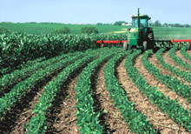GPS equipment manufacturers have developed several tools to help farmers and agribusinesses become more productive and efficient in their precision farming activities. Today, many farmers use GPS-derived products to enhance operations in their farming businesses. Location information is collected by GPS receivers for mapping field boundaries, roads, irrigation systems, and problem areas in crops such as weeds or disease. The accuracy of GPS allows farmers to create farm maps with precise acreage for field areas, road locations and distances between points of interest. GPS allows farmers to accurately navigate to specific locations in the field, year after year, to collect soil samples or monitor crop conditions.

Crop advisors use rugged data collection devices with GPS for accurate positioning to map pest, insect, and weed infestations in the field. Pest problem areas in crops can be pinpointed and mapped for future management decisions and input recommendations. The same field data can also be used by aircraft sprayers, enabling accurate swathing of fields without use of human “flaggers” to guide them. Crop dusters equipped with GPS are able to fly accurate swaths over the field, applying chemicals only where needed, minimizing chemical drift, reducing the amount of chemicals needed, thereby benefiting the environment. GPS also allows pilots to provide farmers with accurate maps.

Farmers and agriculture service providers can expect even further improvements as GPS continues to modernize. In addition to the current civilian service provided by GPS, the United States is committed to implementing a second and a third civil signal on GPS satellites. The first satellite with the second civilian signal was launched in 2005. The new signals will enhance both the quality and efficiency of agricultural operations in the future.

# 6.CONCLUSION

The agricultural sector is of vital importance for the region. It is undergoing a process of transition to a market economy, with substantial changes in the social, legal, structural, productive and supply set-ups, as is the case with all other sectors of the economy. These changes have been accompanied by a decline in agricultural production for most countries, and have affected also the national seed supply sectors of the region. The region has had to face problems of food insecurity and some countries have needed food aid for IDPs and refugees.

Due to the relatively low demographic pressure projected for the future, the presence of some favourable types of climates and other positive factors, including a very wide formal seed supply sector, it should be possible to overcome problems of food insecurity in the region as a whole, and even to use this region to provide food to other food-deficient regions. Opportunities must therefore be created to reach these results.

In order to address the main constraints affecting the development of the national and regional seed supplies that are mentioned here, the region requires integrated efforts by all national and international stakeholders and institutions involved in seed supply and plant genetic resource management. On practical issues, lessons learned by some countries could be shared with other countries; e.g. on how to progress with the transition or how to recognize the most immediate needs of farmers. Appropriate policies should also be established, at various levels, in order to facilitate seed investment and development in the region.

# 7.FUTURE SCOPE

The agricultural sector is of vital importance for the region. It is undergoing a process of transition to a market economy, with substantial changes in the social, legal, structural, productive and supply set-ups, as is the case with all other sectors of the economy. These changes have been accompanied by a decline in agricultural production for most countries, and have affected also the national seed supply sectors of the region. The region has had to face problems of food insecurity and some countries have needed food aid for IDPs and refugees.

Due to the relatively low demographic pressure projected for the future, the presence of some favourable types of climates and other positive factors, including a very wide formal seed supply sector, it should be possible to overcome problems of food insecurity in the region as a whole, and even to use this region to provide food to other food-deficient regions. Opportunities must therefore be created to reach these results.

In order to address the main constraints affecting the development of the national and regional seed supplies that are mentioned here, the region requires integrated efforts by all national and international stakeholders and institutions involved in seed supply and plant genetic resource management. On practical issues, lessons learned by some countries could be shared with other countries; e.g. on how to progress with the transition or how to recognize the most immediate needs of farmers. Appropriate policies should also be established, at various levels, in order to facilitate seed investment and development in the region.

# 8.APPENDIX

A. Source Code

<https://public.tableau.com/app/profile/bhuvaneshwari.m6210/viz/Book1_16969286712860/Story1?publish=yes> <https://public.tableau.com/app/profile/bhuvaneshwari.m6210/viz/Book1_16969286712860/Story2?publish=yes>